**Writing Cookbook on workstation**

**You can validate that you don’t have any cookbooks on chef server**

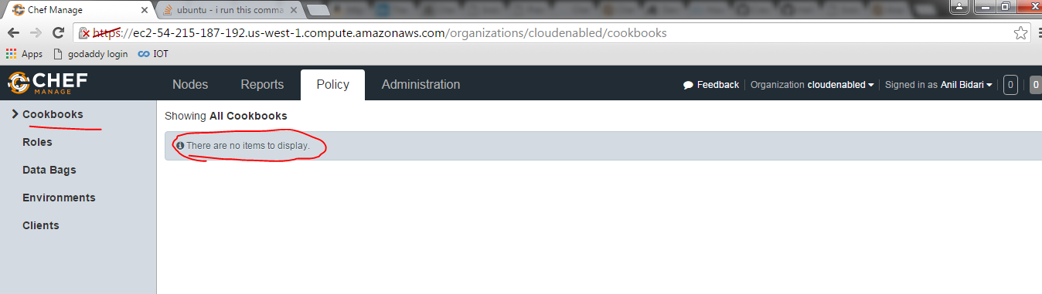

##### **Step 1: Go to our chef-repo**

# cd /home/ubuntu/chef-repo

##### **Step 2: create a cookbook by using knife**

# knife cookbook create apache2

**Step 3: knife does here is builds a simple structure within our cookbooks directory**

# cd /home/ubuntu/chef-repo/cookbooks/apache2

# ls

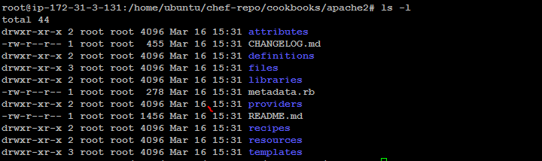

**Step 4: Create a sample recipe**

# vim /home/ubuntu/chef-repo/cookbooks/apache2/recipes/default.rb

package 'apache2' do

action :install

end

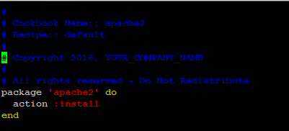

Note:The first line begins with the type of resource (package) and the name of the resource ('apache2').

In this resource, we see action :install. This line tells Chef that the resource we are describing should be installed.